ASA Members:

These documents are provided as a starting point for our members to use when exploring legal issues resulting from the COVID-19 event. Members are cautioned this is not specific or general legal advice, and they should consult their chapter attorney or personal attorney to discuss specific impacts to their company.

ASA acknowledges the contributions of Brian K. Carroll, (ASA Vice-President elect); Bethany Beck (ASA Attorney Council Chair); and Allen Wilson; all with Sanderford & Carroll, P.C. for their assistance in preparing these documents. They can be reached at www.txconstructionlaw.com.

CMRRR
Regular First-Class Mail
Facsimile Number:
E-mail address:

Re: COVID-19 issues

Dear Client,

We have been actively monitoring the fast-moving developments related to the COVID-19 Pandemic, and felt it important to reach out to you regarding concerns and issues you should be aware of from a “legal” and “contractual” perspective, as well as general operating issues for your company that you should be prepared to address in the coming days. Our firm will be actively working throughout this timeframe; however, we are also sensitive to the health and safety concerns of our legal team. As such, if you don’t reach your usual firm attorney by the primary method you communicate with them by, please consider using a secondary communication approach. We anticipate all of our team will be available by email, even if they are not directly reachable by calling any of our offices due to working at home or other steps taken consistent with social distancing recommend by the CDC.

From our vantage point, the issues we feel it is critical to be aware of relate to the following:
- Force Majeure clauses and their effect;
- Differing Site Condition clauses and their effect;
- Safety Concerns; and
- Contractual Notice Requirements.

Each of these concerns will be addressed in more detail in the sections below.

Force Majeure

Force Majeure clauses are common in most construction contracts. In short, the effect of these clauses is to create an excusable, non-compensable delay for events outside of the control or a downstream or upstream party. In the current situation, COVID-19, and the impacts of same, would appear to fit inside most Force Majeure clauses, although “pandemic” is generally not an expressly noted included event. Example language in the AIA contract on force majeure is as follows:

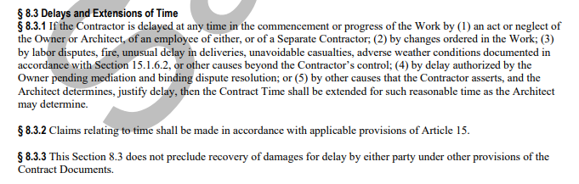

As one can see, an argument can be made that the presence of COVID-19 on a project site is a delay by, “(3) … other causes beyond the Contractor’s control…” As such, the upstream party needs to be placed on notice of a potential claim as soon as possible.

Differing Site Conditions

Different Site conditions (“DSC”) clauses are also very familiar to parties in the construction industry. These are usually associated with unknown conditions such as utility conflicts, geotechnical variations and encountering hazardous materials (asbestos, PCB’s, etc). Given the latter issue of hazardous materials, an argument could be made that to the extent a project site is contaminated by presence of the COVID-19 virus, an argument could be made that a differing site condition existed. An example of the DSC clause from the AIA contract is as follows:

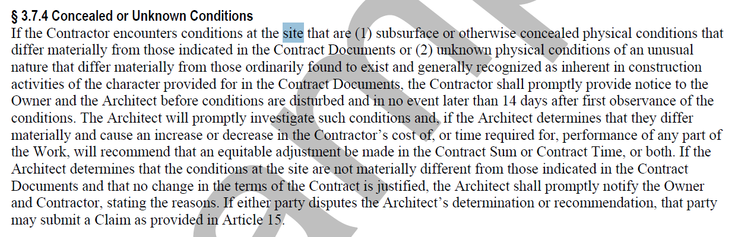

As one can see, and argument can be made that the presence of COVID-19 on a project site is a, “physical condition of an unusual nature that differ[s] materially from those ordinarily found to exists and generally recognized as inherent in construction activities…” As such, the upstream party needs to be placed on notice of a potential claim as soon as possible.

Safety Concerns

As is the mantra of our clients, no job is so important to knowingly risk the life of a team member to accomplish same. Those concerns ring true today, but in a far more different format. We are recommending that to the extent your project sites are still open and have not been closed (do to employee size, quarantine or upstream directive), that you have a tool box safety talk and immediately discuss what is currently known about COVID-19, and the recommendation from CDC and other governmental agents concerning preventing transmission of same. We also recommend that you discuss with your employees what the symptoms are of COVID-19. This safety talk cannot be a high enough priority to protect your employees and those of other contractors/subcontractors on the Project site.

In short, if someone is sick, they do not need be at the job site. If they suspect they are sick or have been around someone who is sick, they do not need to be at the jobsite. When in doubt, socially isolate. Comply with the recommendations of CDC and governmental authorities as to when and how to seek medical attention if someone feels they are ill.

You should also be prepared to address Personal Protective Equipment (“PPE”) issues regarding continued work on project sites. While we are aware of no specific OSHA guidance at this time, if employees demand PPE to continue work on the project site, you need to be prepared to address those concerns. Many trades will already have access to respirators, face shields and other forms of PPE. However, it is unknown at this time the preventive ability of common construction industry PPE against the COVID-19 virus. We caution you if employees request PPE, and you can’t provide same, that it could easily create a legal risk to your company if you force them to work in that situation. The lack of appropriate PPE may also create a force majeure condition as referenced above.

Additionally, make sure you project team has access to facilities to frequently wash their hands with soap and water, and when same is not available appropriate alcohol based hand-cleaner. CDC recommends this as part of the protocol to help slow spread of the virus. It is key in this time period that our teams work smart and safely.

Notice Provisions

In addition to paying attention to force majeure clauses, differing site condition clauses, and other similar clauses, you should also make sure you are familiar with the notice provisions of your contract. Almost every contract has some sort of “notice of claims” type of requirement. The AIA A201-2017 provision is as follows:

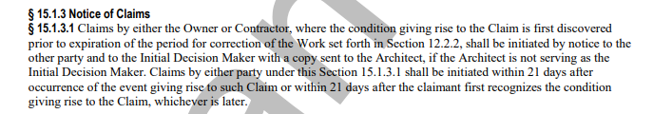

This provision is by far much more forgiving than the majority of notice provisions. Frequently, contractual notice provisions require that you provide notice within five, three, or even one business day. The common theme between what the A201 requires and what your contact likely requires is knowledge of the “condition giving rise to the Claim.” The President declared on Friday March 13, 2020 that COVID-19 was a National Emergency and the CDC declared that COVID-19 was a Public Health Emergency. On Sunday March 15, 2020, the CDC issued guidance that stated that gatherings of greater than 50 people should be cancelled. As this shows, there is a strong argument that “condition[s] giving rise” to any claims related to COVID-19 have occurred. For this reason, we recommend that you immediately issue some sort of notice of potential impact to every one of your customers on every one of your projects. For your convenience, we have attached a form notice letter to this letter for you to adapt to your needs.

Please be aware that your contract may also require an additional notice once your cost impacts have been fully realized. To the extent that you determine it is in your best interest to send a notice of potential impact, we also recommend that you send a follow up notice with your actual or anticipated costs once you have determined the extent of those costs. As always, we are available to assist as needed with this process.

We are here for you

We want you, as our client, to know that we will be continuing normal operations and that should it become necessary, we also have systems in place for all of our attorneys to work remotely. We encourage you to reach out to us as your normally would regarding your legal matters, and look forward to serving your best interests as we all navigate the issues arising during uncertain times such as these. While we will all be available via phone as well, email is likely the best way to reach us during the coming weeks. Please do not hesitate to contact us with further questions.

Sincerely,

Name
Title

[Place on your letterhead]

[insert today’s date]

[Your company name]
[Address]

[Customer Name]
[Customer address]
[identify method of transmission, eg, email/CMRRR#]

Re: Notice of potential impact related to COVID-19, or coronavirus, on [Identify Project] (the “Project”)

To whom it may concern,

The World Health Organization (“WHO”) has declared the outbreak of SARS-CoV-2 and the disease it causes—coronavirus disease 2019 or COVID-19—a global pandemic. According to the Center for Disease Control, coronavirus represents a Public Health Emergency (“PHE”). Recently, the President of the United States has declared the outbreak a national emergency. As such, [your company name] hereby provides notice that any adverse impacts caused by the PHE, the pandemic, and/or coronavirus are outside of our control and may impact our operations on the Project. These impacts may include but are not limited to delayed material orders or shipments, labor shortages, price/labor cost escalations, or other impacts.
The purpose of this letter is to provide you with notice of a potential impact to [Short version of your company name]’s progress and efficiency on the Project as a result of the PHE. It is further intended to reserve all rights related to demobilization costs, overhead impact costs (field office and home office), and any other financial impacts that may result from the PHE. Additionally, it is intended to advise you that if this PHE impacts [Short version of your company name]’s operations on the Project, [your

company name] will exercise its rights to secure additional contract time and money (if applicable). This notice is intended to comply with any relevant notice requirements whether applicable by contract, statute, regulation, caselaw, or other authority.
Finally, should any [customer name] departments, employees, or entities shut down, [Short version of your company name] will: [choose the applicable alternative: continue to work where applicable unless otherwise directed/shut down our operations]. [Short version of your company name] will seek compensation for that work via payment application electronically to avoid person-to-person transmission of COVID-19. In the event that [Short version of your company name] is directed to shut down all operations as a result of the PHE, [Short version of your company name] will submit a payment application for work completed to date electronically in the same method described above. This policy is being implemented company wide and it is not specific to any one project. Consistently, this letter is not intended to reflect negatively on you and is instead intended to protect [Short version of your company name]’s contractual and legal rights. [Short version of your company name] looks forward to working with you during this difficult time.

Thank you,

____________________
[name, title]

